**Figure 1** — Use-case diagram for learning-map prototype.

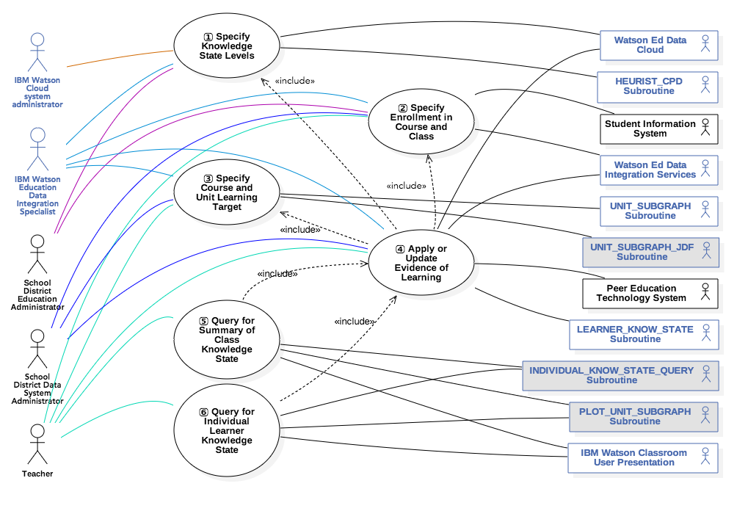

| **Use Case Name**: ⓵ Specify knowledge-state levels | | | **ID**: Proto1 | **Importance Level**: |
| --- | --- | --- | --- | --- |
| **Primary Actors**:   * School-district education administrator (educational) * IBM-Watson Education Cloud system administrator | | Use Case Type: Overview, Essential | | |
| Stakeholders and Interests: | | | | |
| **External System Actors**: | | **Internal System Components**:   * Watson Education Data Cloud * HEURIST_CPD Subroutine | | |
| **Brief Description**: Initially configure offering for school-district through specification of school-district policies for characterization of learner knowledge states. Also initialize a set of template Conditional Probability Distribution (CPD) tables from which a Bayesian-network learning-map is constructed. | | | | |
| **Trigger**: IBM-Watson Education Cloud system administrator initializes service for IBM Watson Classroom  Type: | | | | |
| **Essential Information Inputs**:   * KNOW_STATE_SPEC input table containing jurisdiction policy how implied knowledge state relates to observed evidence of learning for individual learners. | **Essential Information Outputs**:   * CPD_LONG output table containing heuristically derived conditional probability distribution (CPD) table templates by which learning-map model is initialized. | | | |
| Relationships:  Association:  Include:  Extend:  Generalization: | | | | |
| **Normal Flow of Events**:   1. School-district administrator provides KNOW_STATE_SPEC table to IBM. 2. The IBM-Watson Education Cloud system administrator configures the system to support the new client. 3. The IBM-Watson data-integration team uploads the KNOW_STATE_SPEC into the data cloud for the new client. 4. The IBM-Watson Education Cloud system administrator initiates the HEURISTIC_CPD subroutine, which creates a TENANT_ID-indexed instance of CPD_LONG table in the cloud. | | | | |
| SubFlows:  S-1:  S-2: | | | | |
| Alternate/Exceptional Flows: | | | | |

| **Use Case Name**: ⓶ Specify learner enrollment in course and class | | | **ID**: Proto2 | **Importance Level**: |
| --- | --- | --- | --- | --- |
| **Primary Actors**:   * School-district education administrator (registrar?) * School-distract data-system administrator * IBM-Watson Education Data-integration specialist * Teacher | | **Use Case Type**: Overview, Essential | | |
| Stakeholders and Interests: | | | | |
| **External System Actors**:   * STUDENT INFORMATION SYSTEM serves as system of record | | **Internal System Components**:   * Watson Ed Data Integration Services transform enrollment * Watson Education Data Cloud stores enrollment-data tables | | |
| **Brief Description**: Extract learner enrollment in courses from classes and upload into Watson Education Data Cloud. | | | | |
| **Trigger**: School-district registrar enrolls learner in course, class within school-district  Type: | | | | |
| **Essential Information Inputs**: | **Essential Information Outputs**:   * COURSE_ENROLL table contains associations between learners, courses, classes, teachers. | | | |
| **Relationships**:  Association:  Include:  Extend:  Generalization: | | | | |
| **Normal Flow of Events**:   1. School-district education administrator (registrar?) enrolls learner(s) in courses, classes. 2. School-district data-system administrator extracts enrollment information from Student-Information System (SIS). 3. The IBM-Watson data-integration specialist verifies uploading of COURSE_ENROLL table into Watson Education Data Cloud. 4. Teacher verifies course enrollment is accurately reflect in IBM Watson Education Classroom. | | | | |
| SubFlows:  S-1:  S-2: | | | | |
| Alternate/Exceptional Flows: | | | | |

| **Use Case Name**: ⓷ Specify Course and Unit Learning Objectives | | | **ID**: Proto3 | **Importance Level**: |
| --- | --- | --- | --- | --- |
| **Primary Actors**:   * Teacher * Teacher * School-District data-system administrator * IBM-Watson Education data-integration specialist | | **Use Case Type**: Overview, Essential | | |
| Stakeholders and Interests: | | | | |
| **External System Actors**: | | **Internal System Components**:   * Watson Education Data Cloud stores COURSE_UNIT * Watson Ed Data Integration Services transforms the course unit learning-standards scope into COURSE_UNIT table and uploads into IBM Watson data cloud. * UNIT_SUBGRAPH subroutine constructs UNIT_MAP_EDGE_LIST, comprised of all learning-map vertices within a specified radius of those pertaining to in-scope learning standards. * UNIT_SUBGRAPH_JDF (prototype only) calculates the joint-distribution function (JDF) for the learning-map model. | | |
| **Brief Description**: Construct Bayesian-network learning-map model for learning standards within neighborhood of in-scope learning standards. | | | | |
| **Trigger**: Teacher specifies learning-standards scope for current or soon-to-begin course unit.  Type: | | | | |
| **Essential Information Inputs**:   * COURSE_UNIT table specifies “in-scope” learning standards for the current course unit. * CPD_LONG (prototype only) contains the conditional probabilities for the learning map spanning the neighborhood of in-scope learning standards. * SIHLEARNING_STANDARD_PROGRESSION table lists all edges for all learning maps within scope of curriculum covered by IBM Watson Education classroom. | **Essential Information Outputs**:   * UNIT_MAP_EDGE_LIST table contains learning-map graph edge lists for the learning map spanning the neighborhood of the in-scope learning standards. * GRAPHCLUST_N_UNIT_MAP_JDF (prototype only) contains the joint distribution function for all learning-map vertices spanning the learning-map neighborhood. | | | |
| **Relationships**:  Association:  Include:  Extend:  Generalization: | | | | |
| **Normal Flow of Events**:   1. Teacher specifies learning standards within scope of current instructional unit. In-scope standards are captured in a COURSE_UNIT table. 2. School-district data-system administrator and IBM-Watson Education data-integration specialist upload COURSE_UNIT table into Watson Education Data Cloud. 3. The IBM-Watson data-integration specialist verifies uploading of COURSE_ENROLL table into Watson Education Data Cloud. 4. UNIT_SUBGRAPH and UNIT_SUBGRAPH_JDF subroutines construct Bayesian-network model for in-scope learning standards and their neighbors. | | | | |
| SubFlows:  S-1:  S-2: | | | | |
| **Alternate Flows**:   1. Teacher specifies in-scope learning standards through feature in IBM Watson Education Classroom user interface. 2. The IBM-Watson data-integration specialist verifies uploading of COURSE_ENROLL table into Watson Education Data Cloud. 3. UNIT_SUBGRAPH and UNIT_SUBGRAPH_JDF subroutines construct Bayesian-network model for in-scope learning standards and their neighbors. | | | | |

| **Use Case Name**: ⓸ Apply or update evidence of learning | | | **ID**: Proto4 | **Importance Level**: |
| --- | --- | --- | --- | --- |
| **Primary Actors**:   * Teacher * School-District data-system administrator * IBM-Watson Education data-integration specialist | | **Use Case Type**: Overview, Essential | | |
| Stakeholders and Interests: | | | | |
| **External System Actors**:   * Peer Education Technology System (e.g., Learning-management system (LMS), assessments-data-management system) serves as system of record for evidence of learning. | | **Internal System Components**:   * Watson Education Data Cloud stores EoL_MEAS table of measured evidence of learning for all enrolled learners and LEARNER_KNOW_STATE table of estimated learners’ knowledge state for all learning standards within span of learning map represented by UNIT_MAP_EDGE_LIST. * Watson Ed Data Integration Services transforms the course unit learning-standards scope into EoL_MEAS table and uploads into IBM Watson data cloud. * LEARNER_KNOW_STATE subroutine applies evidence of learning to Bayesian network and estimates knowledge state for unmeasured learning standards. | | |
| **Brief Description**: Apply evidence of learning to Bayesian-network learning-map model of learning-standards neighborhood of in-scope learning standards. | | | | |
| **Trigger**: Teacher records evidence of learning in Peer Education Technology System.  Type: | | | | |
| **Essential Information Inputs**:   * EoL_MEAS contains evidence of learning for all enrolled learners. * UNIT_MAP_VERTICES and GRAPHCLUST_N_UNIT_MAP_JDF (prototype only) specify the Bayesian-network learning-map model. * COURSE_ENROLL table contains learners’ associations with courses, classes, and their teachers. | **Essential Information Outputs**:   * LEARNER_KNOW_STATE table contains estimated learner knowledge states for all learners, learning standards within the span of the learning map specified by UNIT_MAP_VERTICES. | | | |
| **Relationships**:  Association:  Include:   * ⓵ Specify knowledge-state levels * ⓶ Specify learner enrollment in course and class * ⓷ Specify Course and Unit Learning Objectives   Extend:  Generalization: | | | | |
| **Normal Flow of Events**:   1. Teacher records evidence of learning in Peer Education Technology System. 2. School-district data-system administrator and IBM-Watson Education data-integration specialist upload EoL_MEAS table into Watson Education Data Cloud. 3. LEARNER_KNOW_STATE subroutine captures all evidence of learning (EoL) for all learning standards in the learning map for learners enrolled in course, class. It applies those evidentiary profiles and states to the Bayesian-network learning-map model and produces LEARNER_KNOW_STATE table, containing probability that each learner’s knowledge state is in the knowledge-state levels categories specified in “⓵ Specify knowledge-state levels”. | | | | |
| SubFlows:  S-1:  S-2: | | | | |
| **Alternate Flows**:   1. Teacher records evidence via feature in user interface for IBM Watson Education classroom. 2. School-district data-system administrator and IBM-Watson Education data-integration specialist upload EoL_MEAS table into Watson Education Data Cloud. 3. LEARNER_KNOW_STATE subroutine captures all evidence of learning (EoL) for all learning standards in the learning map for learners enrolled in course, class. It applies those evidentiary profiles and states to the Bayesian-network learning-map model and produces LEARNER_KNOW_STATE table, containing probability that each learner’s knowledge state is in the knowledge-state levels categories specified in “⓵ Specify knowledge-state levels”. | | | | |

| **Use Case Name**: ⓹ Query for Summary of Class Knowledge State  ⓺ Query for Summary of Class Knowledge State | | | **ID**: Proto5&6 | **Importance Level**: |
| --- | --- | --- | --- | --- |
| **Primary Actors**:   * Teacher | | **Use Case Type**: Overview, Essential | | |
| Stakeholders and Interests: | | | | |
| **External System Actors**: | | **Internal System Components**:   * Watson Education Data Cloud stores LEARNER_KNOW_STATE table of learners’ estimated knowledge state for all learning standards within learning map represented by UNIT_MAP_EDGE_LIST. * IBM Watson Classroom User Presentation (or INVIDUAL_KNOW_STATE_QUERY, PLOT_UNIT_SUBGRAPH subroutines in prototype only) queries LEARNER_KNOW_STATE and provides averages . | | |
| **Brief Description**: Apply evidence of learning to Bayesian-network learning-map model of learning-standards neighborhood of in-scope learning standards. | | | | |
| **Trigger**: Teacher records evidence of learning in Peer Education Technology System.  Type: | | | | |
| **Essential Information Inputs**:   * LEARNER_KNOW_STATE estimated knowledge state for all learners. * COURSE_ENROLL table contains learners’ associations with courses, classes, and their teachers. Used to filter LEARNER_KNOW_STATE. | **Essential Information Outputs**:   * VERTEX_STATE_DIST contains the distribution class averages of knowledge-state probabilities for learning standards within span of learning map (see Figure 2 below). | | | |
| **Relationships**:  Association:   * Include: ⓸ Apply or update evidence of learning   Extend:  Generalization: | | | | |
| **Normal Flow of Events**:   1. Teacher views average knowledge state for all learners enrolled in class for an individual learning standard within scope or within a specified radius of within-scope standards and views representation of knowledge-state conditional probability distribution. | | | | |
| SubFlows:  S-1:  S-2: | | | | |
| **Alternate Flows**:   1. Teacher views average knowledge state for a specific, individual learner enrolled in class for an individual learning standard within scope or within a specified radius of within-scope standards and views representation of knowledge-state conditional probability distribution. | | | | |

**Figure 2** — Exemplary plot of a learner’s estimated knowledge states on a learning map.

